**Draw an E-R diagram for the database presented above**

**Problem 1 Solution:-**

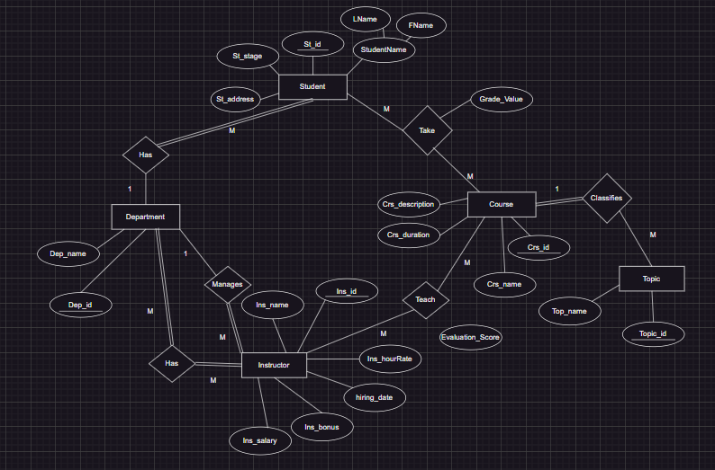

**Problem 2 Solution:-**

**Problem 3 Solution:-**

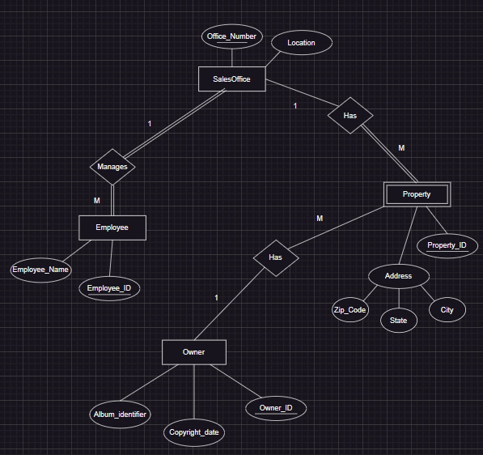

**Problem 4**

**Problem 5**

